Project Development Phase
Model Performance Test

Date | 21 February 2025
Team ID | PNT2022TMIDxxxxxx
Project Name | Salesforce Automation – Data Management using Objects, Fields and Reports
Maximum Marks

Model Performance Testing:
Project team shall fill the following information in model performance testing template.
S.No. | Parameter | Values | Screenshot
1. | Model Summary | Salesforce automation setup for Data management using Object, Fields and Reports.  Import Records: if data matches correctly, records are created; otherwise, an error is shown. | 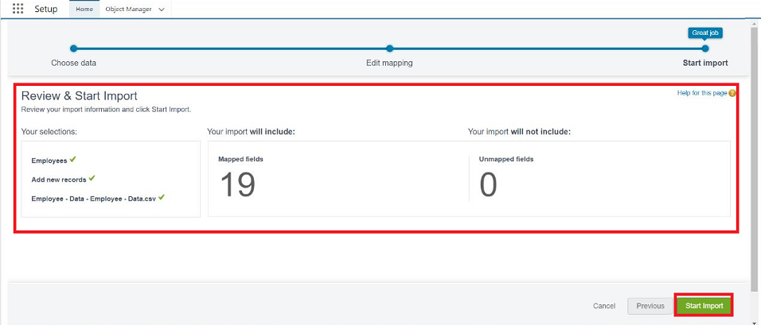
2. | Accuracy | Training Accuracy - 98%  Validation Accuracy - 98% | - 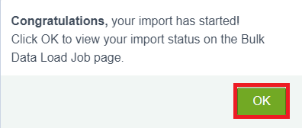
3. | Confidence Score (Only Yolo Projects) | Not Applicable – this is a Salesforce automation/data-management project, not a YOLO object-detection project. Therefore, no YOLO class-detection confidence score is required. | N/A

